**Source 1**

*(Appeal by Lenin to the Red Army, 29 March 1919)*

Comrades, Red Army Men! The capitalists of Britain, America and France are waging war against Russia…they are bringing troops…for the purpose of restoring the rule of the Tsar and the power of landowners and capitalists. But this will not happen. The Red Army has closed its ranks, has risen up and driven the landowners’ troops [away]. A little more effort, a few more months of fighting the enemy, and the victory will be ours. The Red Army is strong because it is consciously and unitedly marching into battle for the peasants’ land, for the rule of workers and peasants, for Soviet power.

Comrades, Red Army men! The alliance of the peasants and workers of the Red Army is firm, close and insoluble. The kulaks, the very rich peasants, are trying to foment revolts against Soviet power, but they constitute an insignificant minority…The peasants know that only an alliance with the workers can vanquish the landowners. Sometimes, people who call themselves Communists…commit acts of injustice and wrong the middle peasant. The workers’ and peasants’ government has firmly decided to fight against these people and clear them out of the countryside. The middle peasants are not enemies but friends of the workers…Comrades, Red Army men! Be staunch, firm and united. March boldly forward against the enemy. Victory will be ours. The power of the landowners and the capitalists, broken in Russia, will be defeated throughout the world.

**Source 2**

*(Russian White Army Civil War poster (1918-1922) Text on the shield* “The God is with us, the Russia will be reborn again" *Text on the bottom:* “Christ has risen" *”)*

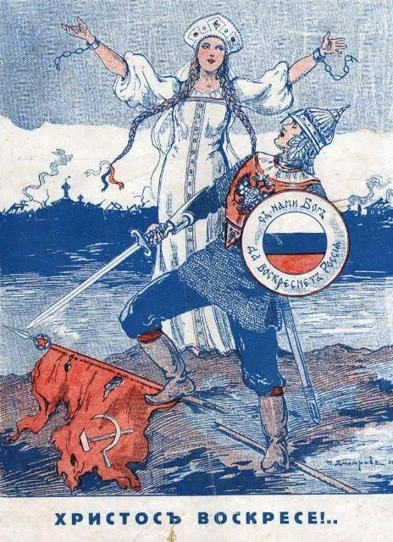

**Source 3** *(Cartoon in* Punch*, 28 January 1920)*

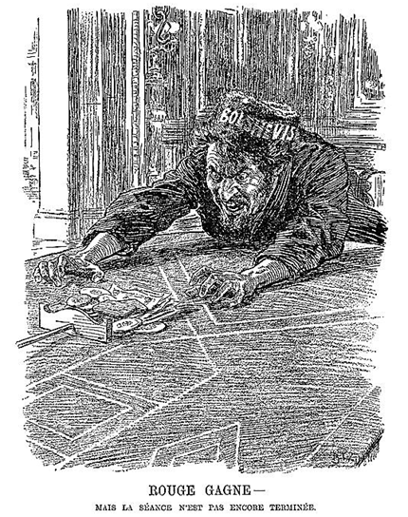**‘Red wins – but the game is not yet over’**

**Source 4**

*(Extract from Orlando Figes,* A People’s Tragedy: The Russian Revolution 1891-1924*)*

For Lenin and most of his followers, civil war was a vital phase in any social revolution… As the Bolsheviks saw it, a civil war was no more than a violent form of class struggle. There was no real distinction in their view between the military conflict and the social conflict in every town and village.

As such, in Lenin’s view, the civil war was to be welcomed as a necessary phase of the revolution. He had always argued that the civil war had been started by the forces of the Right during the summer of 1917, and that the Bolshevik seizure of power should be seen as the joining of the armed struggle by the proletarian side; the class conflicts of the revolution were unresolvable by political means. Russia was split into two hostile camps – the ‘military dictatorship’ and the ‘Dictatorship of the Proletariat’ – and it was a question of which side would prevail. All Lenin’s policies, from the October seizure of power to the closure of the Constituent Assembly and the Treaty of Brest-Litovsk, could be seen…as a deliberate incitement to civil war.